**Daily Scrum or Standup Meeting**

Team name: ________Group 2_________________

Scrum Master: ______Emily_________________

Date:________11/4_______________________

| **Team Member** | **What did you do since the last scrum?** | **What do you plan to do before the next scrum?** | **What obstacles do you have?** |
| --- | --- | --- | --- |
| Emily | Waited 🙂 | Update UI for search results, hook up view customer orders page | Traveling this weekend |
| Andre Nguyen | Wrote a couple unit tests | Finish unit tests and start the documentation | Time! And if I don’t die |
| Maris Hurst | Planned how to do what I need | Write through model and logic to prepopulate a new menu_item based on chosen menu item | other classes |
|  |  |  |  |
|  |  |  |  |

# Burndown

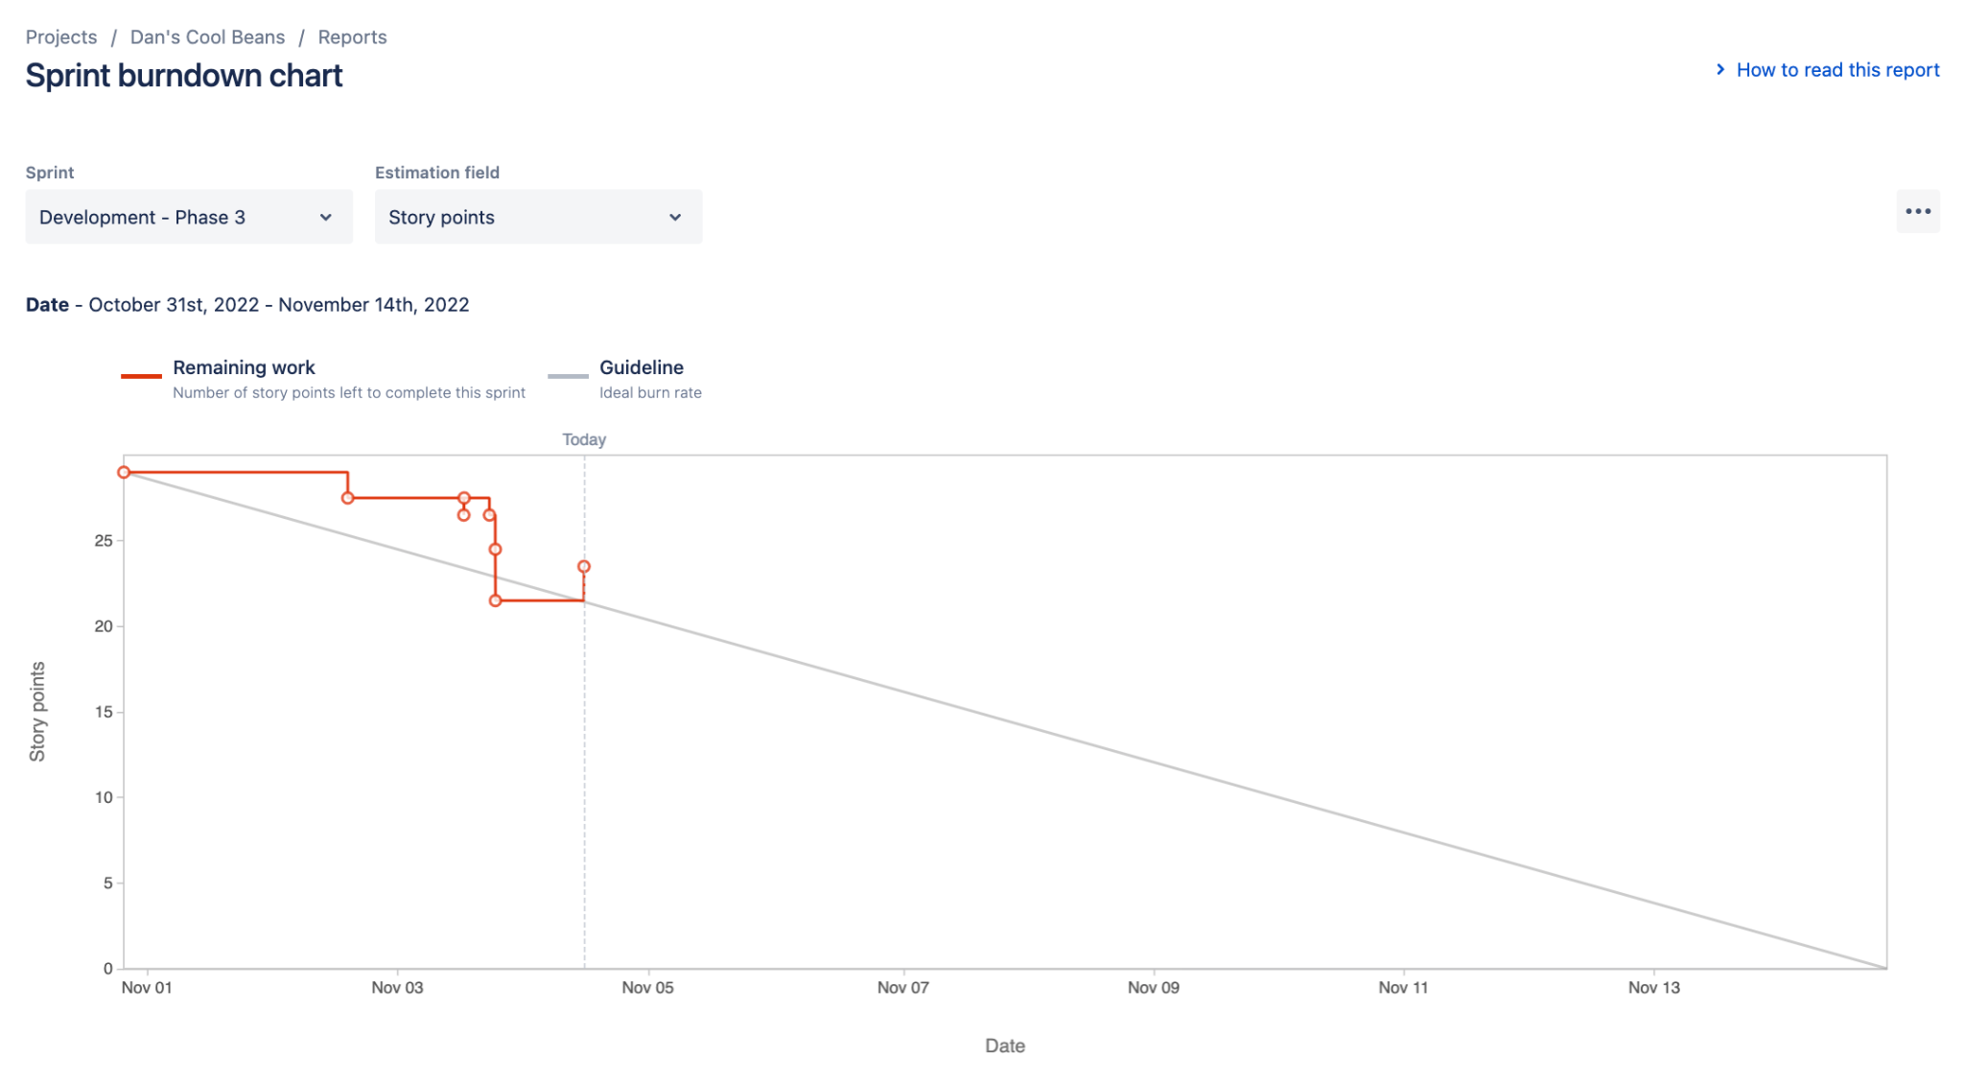

# Screenshot of you project board

